**Sabon Gari/Fagge Cluster**

**Cluster Manager: Pharm Usman Musa Shehu**

**09034394592**

**1. Royal Park Hotel (Aitiken Road, Sabon Gari)**

* Full Name Of The Hotel: Royal Park Hotel

* Full Address With Notable Landmark If Possible: Aitiken Road, Sabon Gari, Kano. (Sabon Gari Is A Notable Commercial And Residential Area).

* Google Address: Yes On Google Address

* Name And Phone Number Of Contact Person For Booking Purpose:

* Contact Person: 09073227682

* Distance In Km To The Conference Venue (Buk New Site) Via The Fastest And Safest Route: Approximately 12-15 Km.

* Facilities Of The Hotel: Complimentary Breakfast, Bar, Pool, Free Wifi.

* Pictures Of The Hotel:



* Available Rooms Disposable To Psn: **100 Rooms Agreed.**

* Rates And Categories Of The Rooms (Negotiated Prices): **₦30,000 - ₦60,000 Per Night**.

2. **Royal Park Hotel (Zungeru Road)**

* Full Name Of The Hotel: Royal Park Hotel

* Full Address With Notable Landmark If Possible: Zungeru Road, Kano.

* Google Address: Royal Park Hotel, Zungeru Rd, Kano

* Name And Phone Number Of Contact Person For Booking Purpose:

* **Contact Person: 08130036738**

* Distance In Km To The Conference Venue (Buk New Site) Via The Fastest And Safest Route: Approximately 10-12 Km.

* Facilities Of The Hotel: Presidential Suites

* Pictures Of The Hotel:

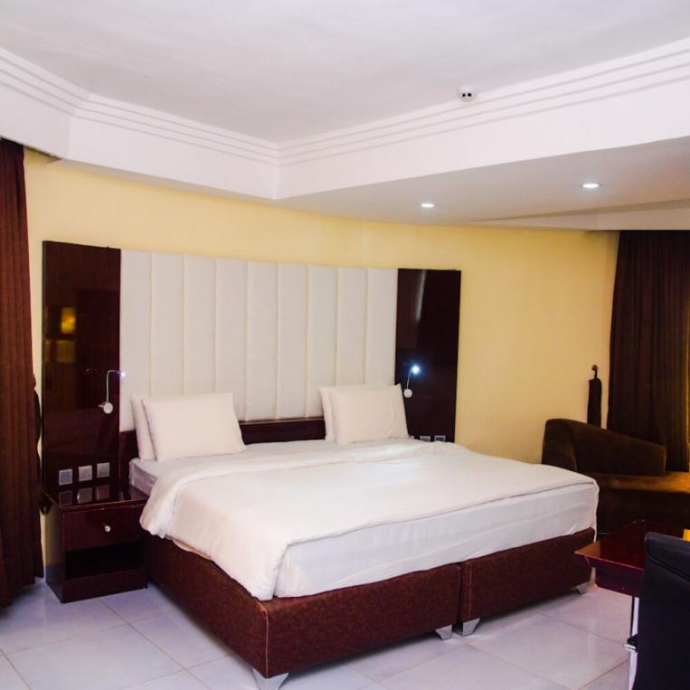

* Available Rooms **Disposable To Psn: 40 Rooms Agreed**.

* Rates And Categories Of The Rooms (Negotiated Prices)**: ₦55,000 Per Night.**

**3. Milton Hotel**

* Full Name Of The Hotel: Milton Hotel (Often Listed As Milton Park Hotel And Resort)

* Full Address With Notable Landmark If Possible: Daura Street, Noman's Land, Sabon Gari, Kano. (Often Listed As 193 Daura Street, Nomansland, Kano). Nomansland Is A Well-Known Area Within Sabon Gari.

* Google Address: "Milton Park Hotel And Resort, 193 Daura Street, Nomansland, Kano".

* Name And Phone Number Of Contact Person For Booking Purpose:

* Phone Number: +234 7036893133

* Distance In Km To The Conference Venue (Buk New Site) Via The Fastest And Safest Route: Approximately 11-14 Km.

* Facilities Of The Hotel: Free Wifi, Bar, Pool And Gym

* Pictures Of The Hotel, The Rooms And Toilets: 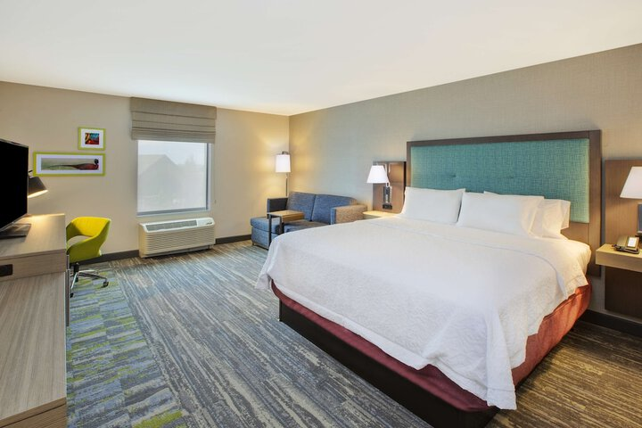

* Available Rooms Disposable To Psn**: 20 Rooms Agreed.**

* Rates And Categories Of The Rooms (Negotiated Prices): **₦30,000 - ₦40,000 Per Night.**

**5. Mozida Suites**

* Full Name Of The Hotel: Mozida Suites

* Full Address With Notable Landmark If Possible: 42/45 Burma Road, Sabon Gari, Kano. (Burma Road Is A Major Road In Sabon Gari).

* Google Address: "Mozida Suites, No. 42/45, Burma Road, Sabon Gari, Kano".

* Name And Phone Number Of Contact Person For Booking Purpose:

* Contact Person: 08035863059

* Distance In Km To The Conference Venue (Buk New Site) Via The Fastest And Safest Route: Approximately 12-15 Km.

* Facilities Of The Hotel: Free Parking, Free High-Speed Internet (Wifi), Pool, Free Breakfast, Bar/Lounge, Airport Transportation, Full-Service Spa, Concierge Services, 24-Hour Room Service, 24-Hour Front Desk, Luggage Storage.

* Pictures Of The Hotel



* Available Rooms Disposable To Psn: **20 Rooms Agreed.**

* Rates And Categories Of The Rooms (Negotiated Prices**): ₦30,000 Per Night.**

**6. Cacid Hotel**

* Full Name Of The Hotel: Cacid Hotel (Also Listed As Cacid Hotels Or Cacid Guest House)

* Full Address With Notable Landmark If Possible: No 1 Sarkin Yaki, Burma Road, Sabon Gari, Kano. (Sarkin Yaki Is A Street Off Burma Road).

* Google Address: "Cacid Hotels, 1, By Sarki Yaki, Burma Rd, Fagge, Kano 700211, Kano".

* Name And Phone Number Of Contact Person For Booking Purpose:

* Contact Person: 07038342756

* Distance In Km To The Conference Venue (Buk New Site) Via The Fastest And Safest Route: Approximately 12-10 Km.

* Facilities Of The Hotel: All Amenities Such As Restaurant, Bar, Security, 24-Hour Electricity, Adequate Parking.

* Pictures Of The Hotel:

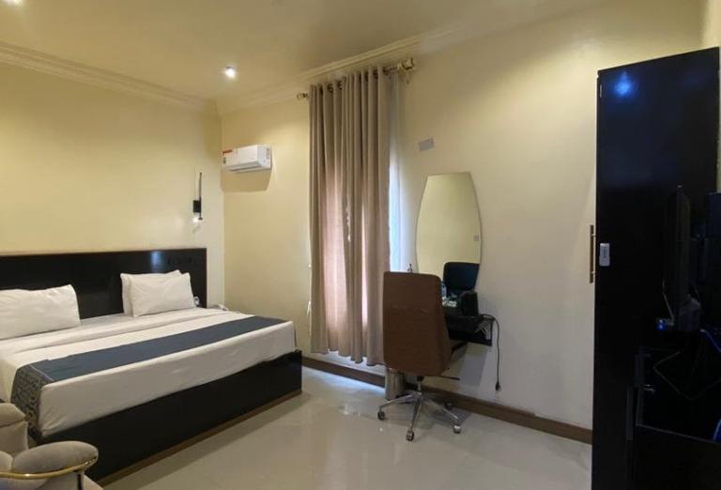

* Available Rooms Disposable To Psn: **20 Rooms Agreed**.

* Rates And Categories Of The Rooms (Negotiated Prices**): ₦35,000 - ₦45,000 Per Night. Higher Categories Like Protocol Room ₦70,000, Suite ₦75,000, Apartment Twin Hub ₦150,000**

**7. Hotel La Mirage**

* Full Name Of The Hotel: Hotel La Mirage (Also Listed As Motel La Mirage)

* Full Address With Notable Landmark If Possible: F 27, Enugu Road, Sabon Gari, Kano. (Enugu Road Is A Significant Street In Sabon Gari).

* Google Address: "Motel La Mirage, No 27 Enugu Road, Sabon Gari, Kano, Nigeria".

* Name And Phone Number Of Contact Person For Booking Purpose:

* Contact Person: 08032129720

* Distance In Km To The Conference Venue (Buk New Site) Via The Fastest And Safest Route: Approximately 10-12 Km.

* Facilities Of The Hotel: All Amenities .

* Pictures Of The Hotel :



* Available Rooms Disposable To Psn: **40 Rooms Agreed.**

* Rates And Categories Of The Rooms (Negotiated Prices**): ₦35,000 - ₦60,000 Per Night.**

**8. 5 Star Saint Hotel And Suites**

* Full Name Of The Hotel: 5 Star Saint Hotel And Suites

* Full Address With Notable Landmark If Possible: 42, Ijebu Road, Sabon Gari, Kano. (Ijebu Road Is A Known Street In Sabon Gari).

* Google Address: "5 Star Saint Hotel, 42 Ijebu Rd, Kano, 700211, Kano, Nigeria".

* Name And Phone Number Of Contact Person For Booking Purpose:

* Contact Person: 09028707777

* Distance In Km To The Conference Venue (Buk New Site) Via The Fastest And Safest Route: Approximately 10-12 Km.

* Facilities Of The Hotel: All Amenities (No Pool). Amenities Include Complimentary Continental Breakfast, Free Wireless Internet Access, Private Balconies (In Rooms), Private Bathrooms, Free Valet Parking.

* Pictures Of The Hotel:



* Available Rooms Disposable To Psn**: 25 Rooms Agreed**.

* Rates And Categories Of The Rooms (Negotiated Prices**): ₦30,000 - ₦55,000 Per Night.**

**9. Ocean Palace Guest Inn**

* Full Name Of The Hotel: Ocean Palace Guest Inn

* Full Address With Notable Landmark If Possible: 35 Warri Road, Sabon Gari, Kano. (Warri Road Is A Known Street In Sabon Gari).

* Google Address: "Ocean Palace Guest Inn, 35 Warri Rd, Sabon Gari, Kano".

* Name And Phone Number Of Contact Person For Booking Purpose:

* Contact Person: 08081750879

* Distance In Km To The Conference Venue (Buk New Site) Via The Fastest And Safest Route: Approximately 10-12 Km.

* Facilities Of The Hotel: Free Parking, Wi-Fi, Swimming Pool, Restaurant, Bar/Lounge, Laundry

* Pictures Of The Hotel:



* Available Rooms Disposable To Psn**: 25 Rooms Agreed.**

* Rates And Categories Of The Rooms (Negotiated Prices): **₦25,000 - ₦50,000 Per Night.**

**10. International Hotel**

* Full Name Of The Hotel: International Hotel

* Full Address With Notable Landmark If Possible: No 34 Enugu Road, Sabon Gari, Kano. (Enugu Road Is A Significant Street In Sabon Gari).

* Google Address: "International Hotel, 30, Enugu Road, Fagge, Kano".

* Name And Phone Number Of Contact Person For Booking Purpose:

* Contact Person: 08034212666

* Distance In Km To The Conference Venue (Buk New Site) Via The Fastest And Safest Route: Approximately 10-12 Km.

* Facilities Of The Hotel: Restaurant,Bar/Longe

* Pictures Of The Hotel:

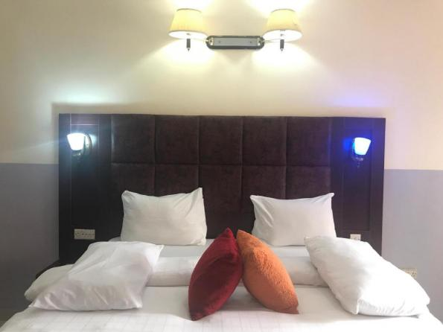

* Available Rooms Disposable To Psn: **50 Rooms Agreed**.

* Rates And Categories Of The Rooms (Negotiated Prices**): ₦30,000 - ₦45,000 Per Night.**

**11. Gab Hotel**

* Full Name Of The Hotel: Gab Hotel (Also Listed As Gap Hotel)

* Full Address With Notable Landmark If Possible: No 42 Ibrahim Tayo Road (Also Listed As Ibrahim Taiwo Road). This Is A Major Road. (Some Sources Add "Along Katinkori Market, Fagge, Kano").

* Google Address: "Gap Hotel, 42, Ibrahim Taiwo Road, Fagge, Kano".

* Name And Phone Number Of Contact Person For Booking Purpose:

* Contact Person: 08162520790

* Distance In Km To The Conference Venue (Buk New Site) Via The Fastest And Safest Route: Approximately 10-12 Km.

* Facilities Of The Hotel: Limited Amenities.

* Available Rooms Disposable **To Psn: 30 Rooms Agreed.**

* Rates And Categories Of The Rooms (Negotiated Prices): **₦22,000 - ₦32,000 Per Night.**

**12. Amingo Hotel**

* Full Name Of The Hotel: Amingo Hotel (Also Listed As Amiingo Hotels)

* Full Address With Notable Landmark If Possible: 22, Kano Middle Road, By Court Road, Sabon Gari, Kano. (Middle Road And Court Road Are Prominent Streets In Sabon Gari).

* Google Address: "Amiingo Hotels, 20 Middle Rd, Fagge, Kano 700213, Kano, Nigeria"..

* Name And Phone Number Of Contact Person For Booking Purpose:

* Contact Person: 09073227682

* Email: Reservations@Amiingohotels.Com

* Distance In Km To The Conference Venue (Buk New Site) Via The Fastest And Safest Route: Approximately 10-12 Km.

* Facilities Of The Hotel: 5-Star Hotel With All Amenities. Including Swimming Pool, Cable Tv, Free Internet, Towels, Air Conditioning, Free Parking, Desk, Heating, Wifi, Balcony/Terrace, Elevator, Oven, Microwave, Dishes & Kitchen Utensils, Refrigerator, 24-Hour Room Service, Telephone, Shower, Jacuzzi. Complimentary Breakfast Available For Some Room Types.

* Pictures Of The Hotel:

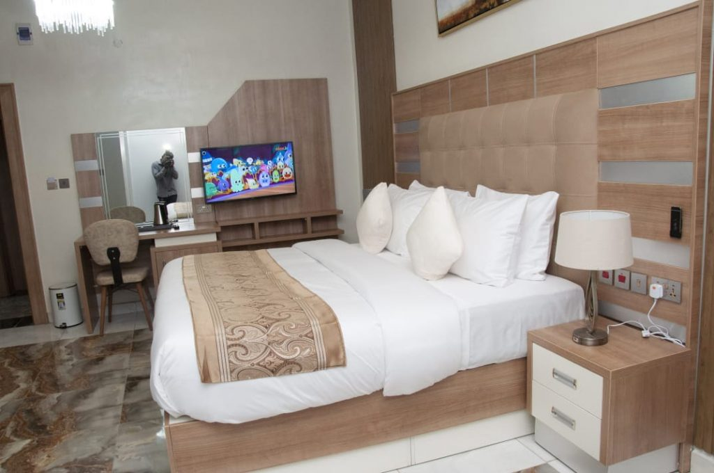

* Available Rooms Disposable To Psn: **30 Rooms Agreed**.

* Rates And Categories Of The Rooms (Negotiated Prices**): ₦51,000 - ₦59,000 Per Night.**

**13. Mandela Hotel**

* Full Name Of The Hotel: Mandela Hotel (Also Listed As Mandela Hotels And Suites)

* Full Address With Notable Landmark If Possible: No 19/21 Middle Road, Sabon Gari, Kano. (Middle Road Is A Prominent Street In Sabon Gari).

* Google Address: "Mandela Hotels And Suites, 21 Middle Rd, Kano, Kn, Ng".

* Name And Phone Number Of Contact Person For Booking Purpose:

* Contact Person: 08069190830

* Distance In Km To The Conference Venue (Buk New Site) Via The Fastest And Safest Route: Approximately 10-12 Km.

* Facilities Of The Hotel: Complimentary Breakfast. Other Amenities Include Restaurant, Bar/Lounge, Security, 24 Electricity, Adequate Parking, Luggage Storage, Room Service, Dstv, Air Conditioning, Refrigerator, Toiletries, Flatscreen Tv.

* Pictures Of The Hotel:

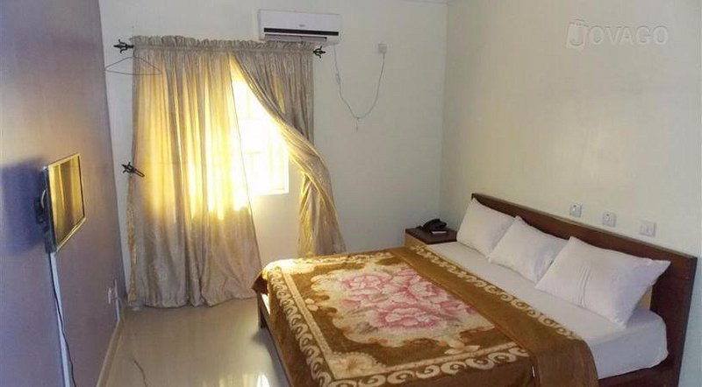

* Available Rooms Disposable **To Psn: 20 Rooms.**

* Rates And Categories Of The Rooms (Negotiated Prices): **₦23,000 - ₦25,000 Per Night** (Subject To Increase). (Standard Room Is Mentioned As A Room Type).

**Farm Centre, Naibawa Zaria Road Axis**

**Cluster Manager: Pharm Luqman, Abbas Umar**

**07031698451**

1. **Danyaya Guest Inn**

Full Address (Include Notable Landmark):Foundation Road, Adjacent To Naptip, Tarauni

Google:Foundation Road, Tarauni Kano State.

Contact:08062076330

Distance To Buk New Site:22KM

Amenities: None

No Of Rooms Allocated To **Psn:10**

Price:**30K To 65K**

Photo:

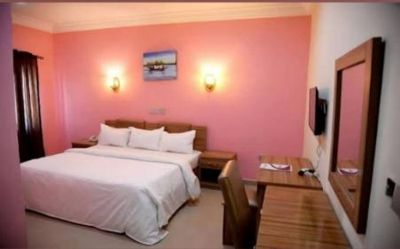

1. **Guest Pride Hotel**

Address:Behind Bristol Palace, Farm Centre

Google:Guest Pride Hotel,Farm Centre Kano

Contact Person:08163384433

Distance To Buk New Site:21KM

Amenities:Complimentary Breakfast, Free Wifi, Gym

No Of Rooms **Tenable To Psn:20**

**Price:78K-201K**

Picture:

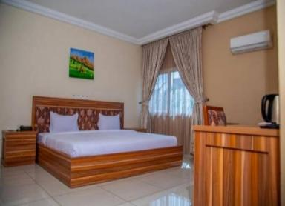

1. **City Centre Hotel**

Address:Behind Bristol Palace, Farm Centre

Google:City Centre Hotel, Farm Centre, Kano State

Contact Person:09082500005

Distance To Buk New Site:21KM

Amenities:Complimentary Breakfast, Free Wifi, Gym,Pool

No Of Rooms Tenable To Psn:25

Price:**40K-114K**

Picture:

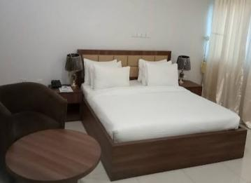

1. **Bayco Hotel**

Address:No 259 Kwanar Masallaci, Zaria Road

Google:Bayco Zariaa Road Kano

Contact Person:08060502848

Distance To Buk New Site:20KM

Amenities:Complimentary Breakfast

No Of Rooms **Tenable To Psn:26**

Price:**19K-35K**

Picture:

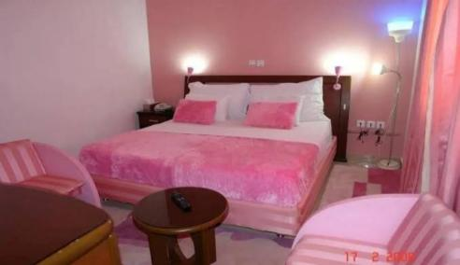

1. **Rayhaan Hotel**

Address:Opposite School Of Nursing Akth, Zaria Road

Google:Rayhaan Hotel, Zaria Road

Contact Person:07032800637

Distance To Buk New Site:

Amenities:, Free Wifi, Gym

No Of Rooms Tenable To Psn:25

Price:**33K-96K**

Picture:

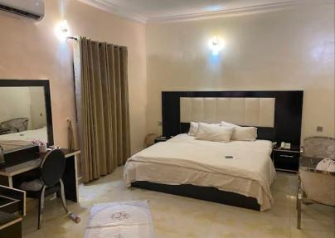

1. **Horizon Hotel**

Address:Miller Road, Fagge, Kano

Contact Person: 07041127408

Distance To Buk New Site:20KM

Amenities:Complimentary Breakfast, Free Wifi, Gym

No Of Rooms Tenable **To Psn:20**

Price:**35K-130K**

Picture:

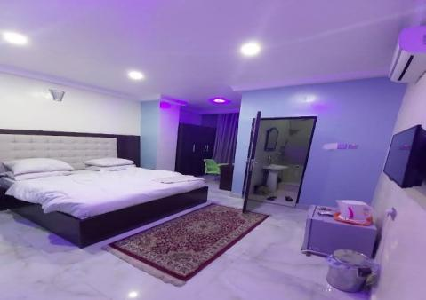

**Nassarawa Gra Axis**

Cluster Manager: Pharm. Nabila Sadiq

08030646511

1. **R&K Guest Palace**

* No 5 Magajin Rumfa Road Close To Dstv Office
* Contact For Reservations And Enquiries 09022009040
* Categories And Prices Of Rooms Per Night

1. Standard Room N37,000
2. Deluxe Pool Side N 40,000
3. Pent House N65,000
4. 2 Bedroom Apartment N100,000
5. 3 Bedroom Apartment N200,000

Nb: **All Rates Are Exclusive Of Breakfast, No Wi Fi**

**Picture:**

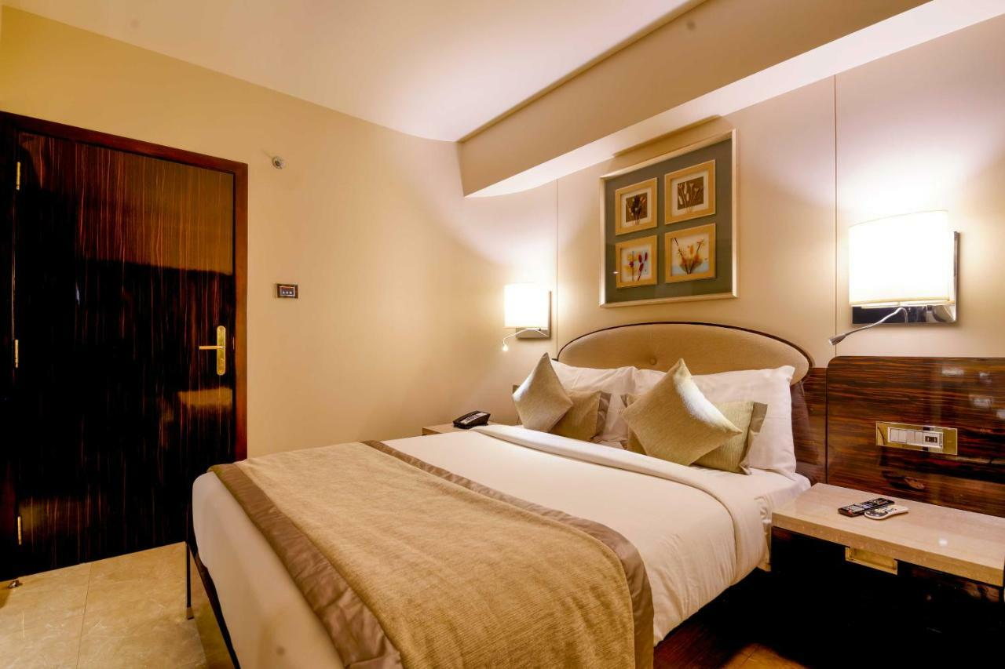

1. **Comfort Hub And Suites**

* Bakatsina By Danbazau Road Along Ahmadu Bello Way,Near Govt House
* Contact For Reservations And Enquiries 07041127408
* Categories And Prices Of Rooms Per Night

1. **Deluxe Suites N91,250**
2. **Super Deluxe Suites N115,000**
3. **Business Suites N243,000**
4. **Royal Suites N291,600**
5. **Premium Suites N364,500**

Pictures:

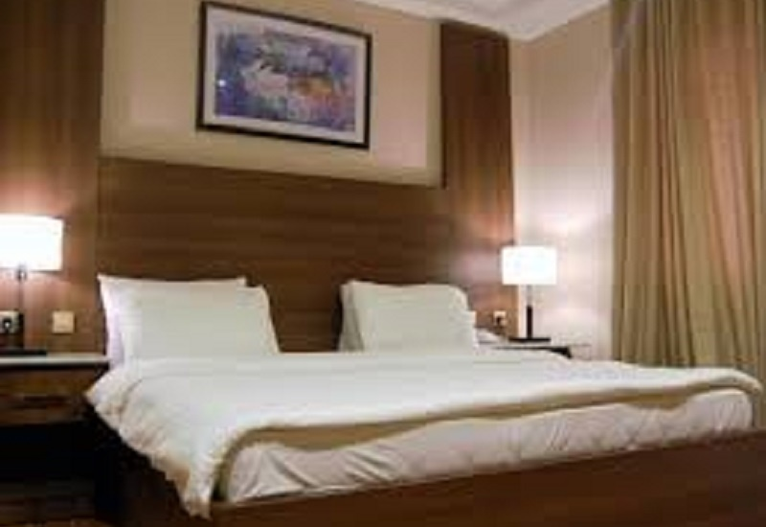

**Nb:Charges Above Are Inclusive Of Complimentary Breakfast, Wi Fi, Gym And Swimming Pool**

1. **Sarina Suites And Apartments**

* 481 Suleiman Cresent Close To Aminudeen Central Mosque And Niima Guest Palace
* Contact For Reservations And Enquiries 09029333383,09121272721
* Categories And Prices Of Rooms Per Night

1. **Deluxe N30,000**
2. **Basic N40,000**
3. **Royal Suite N65,000**
4. **Executive Suite N130,000**
5. **3 Bedroom Apartment N250,000**

Picture:



**Nb:Charges Are Exclusive Of Breakfast, No Wi Fi**

1. **Royal Residency**

* No 96 Lamido Crescent Close To Providian Diagnostic Centre
* Contact For Reservations And Enquiries 07078902101(Manager)
* Categories And Prices Of Rooms Per Night

1. **Standard N60,000**
2. **Deluxe N65,000**
3. **Executive N75000**
4. **Suite N125,000**
5. **Presidential 155,000**

Picture:



Nb: **Charges Inclusive Of Complimentary Breakfast, Wi If And Gym**

1. **Sunbelt Hotel**

* No 36 Lamido Crescent Adjacent To Eha Clinics
* Contact For Reservations And Enquiries 08064894586(Manager)
* Categories And Prices Of Rooms Per Night

1. Standard N120,000
2. Deluxe N138,000
3. Vip Suite N258,000
4. Presidential N298000

Picture:

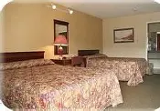

Nb: Complimentary Breakfast, Internet Access, Gym And Pool All Inclusive.

1. **Babale Suites**

* No 8,Dabo Mohammed Close Off Race Course Road
* Contact For Reservations And Enquiries: Mr Edwin (Manager) 08054414715
* Categories And Prices Of Rooms Per Night

**1.Standard N55,000**

**2. Executive N60,000**

**3. Royal N65,000**

**4. Suites N81,000**

Picture:



Nb: Complimentary Breakfast Inclusive, No Wifi,10% Discount

1. **Quarter House Hotel**

* No 1 Tamandu Close,Off Audu Bako Way Nassarawa Gra.
* Contact For Reservations And Enquiries 08100935004,09021684030
* Categories And Prices Of Rooms Per Night

1. **Standard N40,000**
2. **Deluxe N50,000**
3. **Luxury Suite N65,000**
4. **Royal Suite N120,000**

Picture:

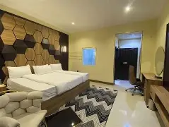

**Nb: Breakfast And Free Wi Fi Inclusive**

1. **Chilla Luxury Suites**

* No 110 Audu Bako Way Close To Magwan
* Contact For Reservations And Enquiries 08169096817,08152525275
* Categories And Prices Of Rooms Per Night

1. **Deluxe N40,000**
2. **Royal Suite N50,000**
3. **Luxury Suite N60,000**
4. **Executive Suite N70,000**
5. **Diplomat Suite N80,000**
6. **Presidential Suite N400,000**

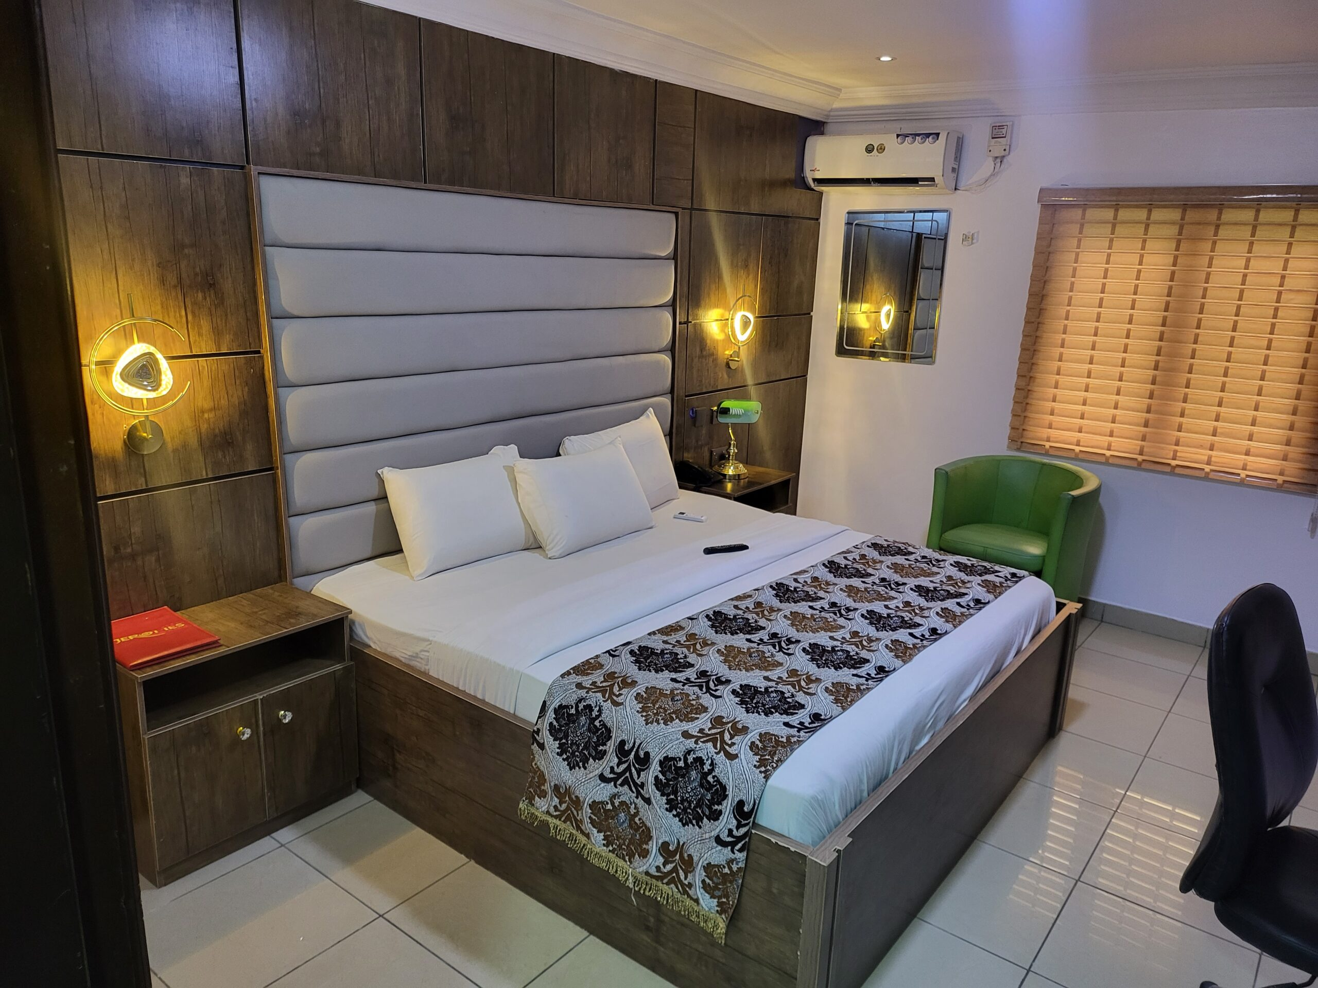

**Nb: Breakfast And Free Wifi Inclusive**

1. **Prince Hotel**

* Tamandu Close, Off Audu Bako Way Behind Nassarawa Hospital
* Contact For Reservations And Enquiries 08033773923,080837166691,08097697979
* Categories And Prices Of Rooms Per Night

1. **Standard N60,750**
2. **Executive N72,900**
3. **King Size N85,050**
4. **Twin Bed N109,350**
5. **Vip N121,500**
6. **Royal N170,100**
7. **Ambassador Suite N218,700**
8. **Imperial Suite N267300**
9. **Presidential Suite N315,900**

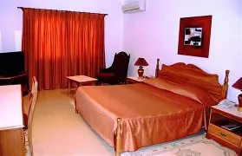

**Nb: Only Free Wi Fi All Other Amenities Are Charged Individually**

1. **Tahir Guest Palace**

**Available Rooms 150**

**Full Amenites**

**Ibrahim Natsugune Road, Nassarawa Gra**

**Contact For Reservation**

1. **Niimah Guest Palace**

* No 8b, Suleiman Crescent Off Ahmadu Bello Way.
* Contact For Reservation And Enquiries 08034523525
* Categories And Prices Of Rooms Per Night

1. **Standard N45,000**
2. **Business Suite N70,000**
3. **Executive Suite N80,000**

Nb: All Hotel Amenities Are Charged Individually.

Picture:



1. **Bizarre Luxury Apartments**

* No 14a Abdullahi Bayero Road
* Contact For Reservations And Enquiries 08106972067
* Categories And Prices Of Rooms Per Night

1.**Standard N45,000**

**2.Business Suite N55,000**

**3.Royal Suite N76,000**

**4.Executive Suite N100,000**

Picture:

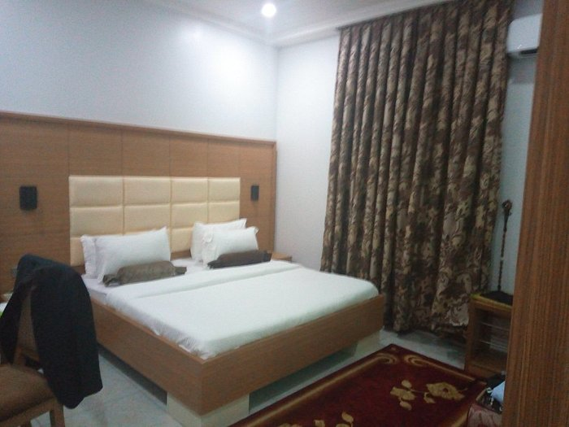

1. **Porto Gulf Hotel**

* No 13d Isa Dutse Street Off Umaru Babura Road
* Contact For Reservations And Enquiries 07074861288
* Categories And Prices Of Rooms Per Night

1. **Standard N80,000**
2. **Premium Standard N98,000**
3. **Executive Suite N130,000**
4. **Ambassador Suite N150,000**



Nb**: Complimentary Breakfast, Free Wi Fi Inclusive**

### ****Haitel Guest Inn****

**Distance:** ~12.8 Km From Rijiyar Zaky Area

Number|:07057771144

**Facilities:** Pool, Restaurant, Bar, Free Breakfast, Room Service, Wi‑Fi, Valet Parking, Laundry, Air-Conditioned Rooms, Toiletries Included

**Rates:** **~35K To 100K/Night**

Picture:

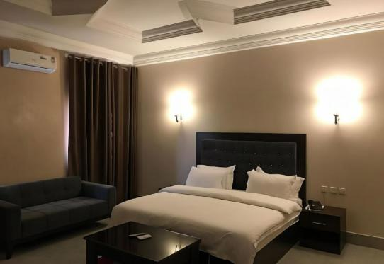

Availability: 20 Rooms

1. **Chimcherry Hotel**

Address:No 21 Aliyu Maliama Barnawa [Sabon Gari](https://hotels.ng/hotels-in-kano/sabon-gari), [Kano](https://hotels.ng/hotels-in-kano)

Distance To Buk: 13km

**Price:20K**

Amenities:Pool, Wi‑Fi, Restaurant:

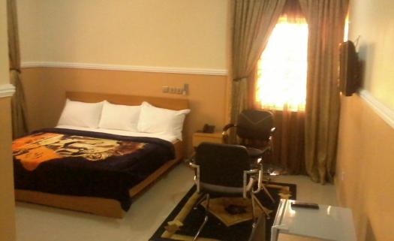

**Rooms For Psn: 15 Rooms**

**BUK Cluster**

Mt Sulaiman

08068144298

1. **Buk Guest House Old Site**

Ten (10) Rooms Available

**20,000 To 30,000 Price Range**

Kitchen 8:00AM To 9:00PM, Power (Generator 6:30 To 7:00AM)

Diatsnce 8.6 Km

Contact 07030875753, (Manager) 08162298937 (Reception)

1. **Buk New Site (NOT READY YET)**

Contact Psn Kano

Available Rooms 190

24hr Electricity, Gym, Restaurant

500 Meters From Conference Venue

1. Z**amin Suites**

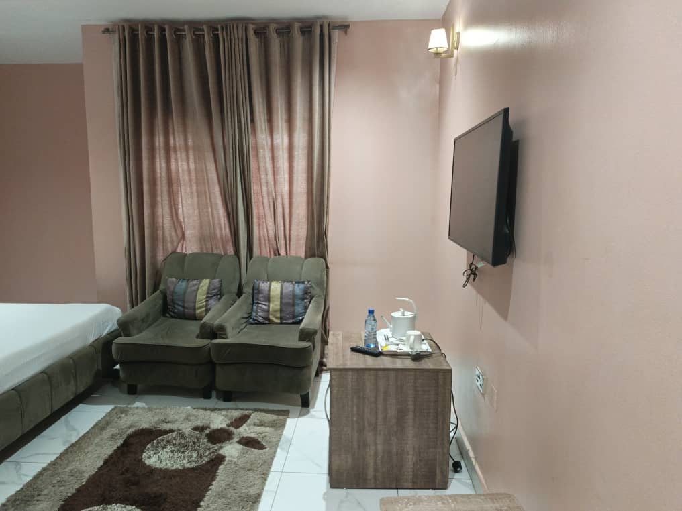

**C**ontact Person (Manager)

08034626290, 09034446878

No 933 Kabuga Satellite Town Tudun Yola, Off Jega Street

**Price Range: 35,000 To 45,000**

Approximate Distance To Conference Venue: 6KM

Amenities; Wifi, Complementary Breakfast, Garden, 24 Hour Power

Available Rooms; 10

1. **Zeen Noor Hotels.**

Contact (Manager) 07036984396

Plot C 45 Kabuga Satellite Town Off Gwarzo Road, Rafin Dannana.

Available Rooms; 60

Price Range **25,000 To 75,000**

Amenities; Electricity 24 Hours, Wifi Complementary Breakfast For Rooms With Rate Of 65,000 To 75,000, Others Negotiable.

1. **Kanem Suits**

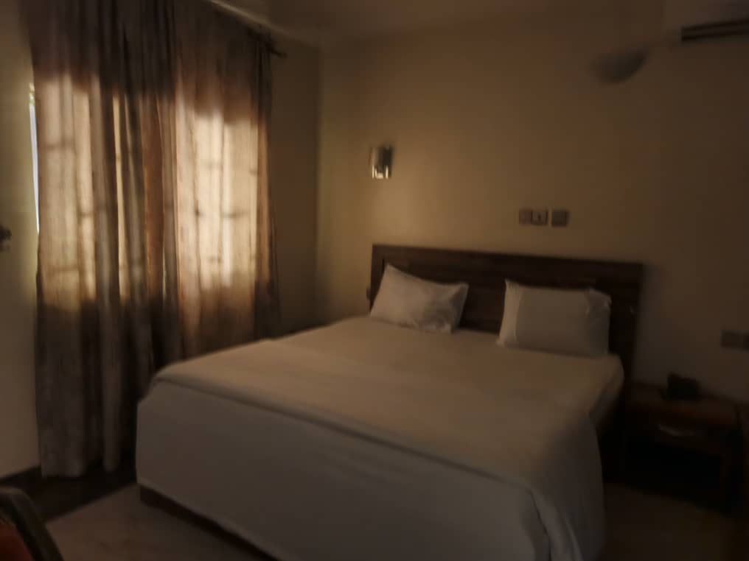

Nndc Qtrs. Off Yahya Gusau Road Behind Makkah Eye Hospital Gadon Kaya Kano.

Contact (Manager) 07065596999

Rates; **30,000 To 65,000**

Amenities; Complementary Breakfast, 24 Hour Power,

Available Rooms 30

Average Distance To Conference Venue; 9.2 Km

**Airport Cluster**

Mt Sulaiman

08068144298

1. **Hilton Palace**

* Full Name Of The Hotel: Hilton Palace (Often Listed As Hilton Palace Limited)

* Full Address With Notable Landmark If Possible: Off Zungeru Road, Sabon Gari, Kano. (Often Listed As No 6, Hilton Close, Hajj Camp Roundabout, Airport Road Kano). This Suggests It's Near The Hajj Camp Roundabout, Which Is A Significant Landmark.

* Google Address: "Hilton Palace Limited, No 6, Hilton Close, Hajj Camp Roundabout, Airport Road Kano".

* Name And Phone Number Of Contact Person For Booking Purpose:

* Phone Number: +234 7066666030

* Email: Reservations@Hiltonpalacehotels.Com

* Distance In Km To The Conference Venue (Buk New Site) Via The Fastest And Safest Route: Approximately 11-13 Km.

* Facilities Of The Hotel: All Amenities (As Per Your List), Including Swimming Pool, Bbq Facilities, Free Wifi, Free Parking, Airport Shuttle, Spa, Fitness Center, Hot Tub/Jacuzzi, Themed Dinners, Personal Trainer, Live Sports Events (Broadcast), Spa Lounge/Relaxation Area, Locker Rooms, Fitness Classes, Live Music/Performance, Entertainment Staff, Movie Nights, Yoga Classes.

* Pictures Of The Hotel, The Rooms And Toilets:



* Available Rooms Disposable To Psn: 70 Rooms Agreed.

* Rates And Categories Of The Rooms (Negotiated Prices**): ₦40,000 - ₦150,000 Per Night.** (Room Options Include Suite).

1. **Green Desert Palm Hotel**

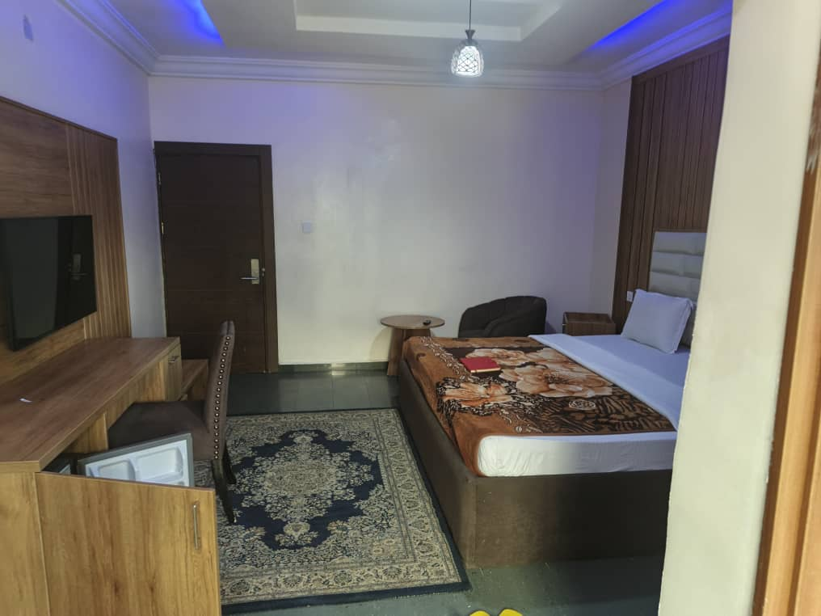

Address; F1/F2 Hajj Camp Round About. Machinama Street

Average Distance To Conference Venue; 15KM

Contact Person (Manager); 08036453599

Available Rooms; 60

Price Range**; 32,000 To 73,000**

Amenities; Wifi, 24 Hour Power, 24 Hr Kitchen And Restaurant

1. **Zaytun Hotel**

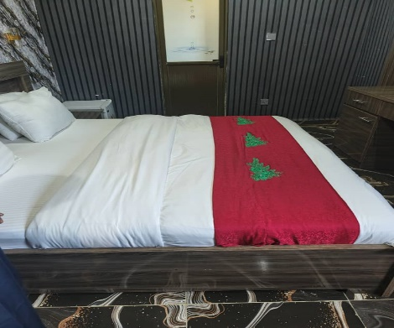

Zungeru Road, Baban Gwari Roundabout

Average Distance To Conference Venue; 15KM

Contact Person (Manager) 08055720045

Available Rooms; 25

Price Range; 28,500 To 40,000

Amenities; Wifi, 24 Hour Power, Kitchen And Restaurant, Pool

1. **Kabo Guest Inn**

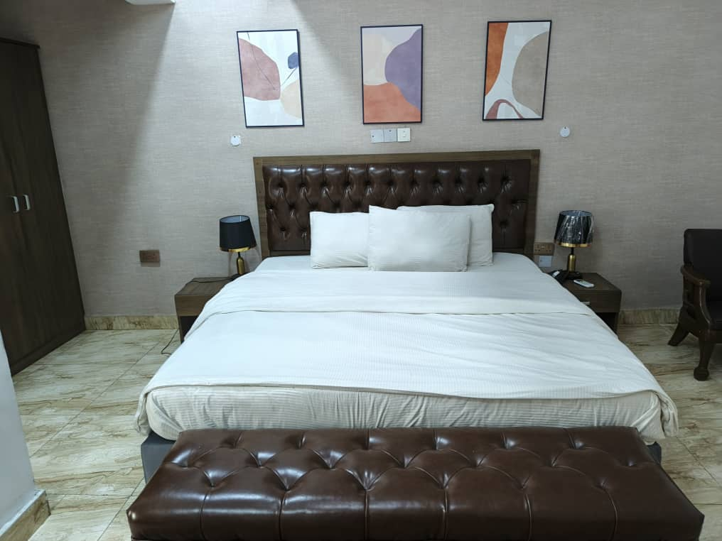

Ashton Road. First Right Turn From The Airport Immediately After Armed Forces Hospital

Contact 08036055248

**Rates 25,000 To 40,000**

No Of Rooms 20.

24 Hrs Kitchen.

Air Condition 10PM To 6AM (In The Absence Of Nepa)